

ICT Department

Dynamite Web Application

Project: Golf website/system

Team Members:

* Chea Sopanharith
* Touch Teng
* Yorn Ngornsreng
* Suos Rothana
* Soeun Sreykhuoch
* Thai Sereywathana

Sitemap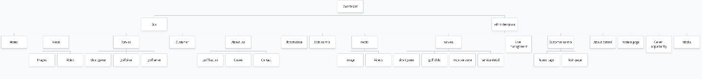

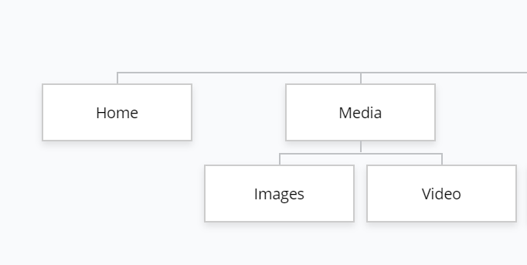

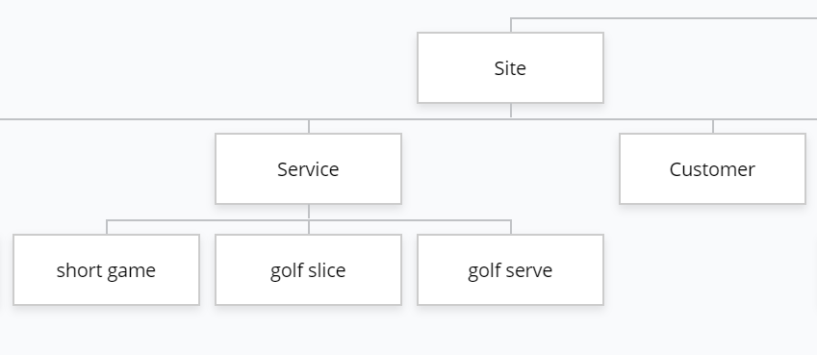

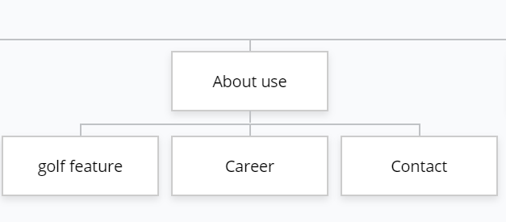

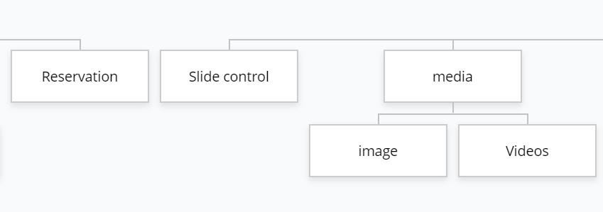

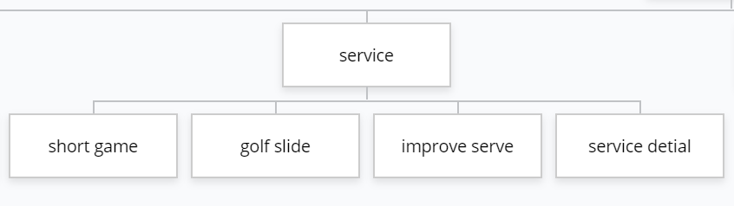

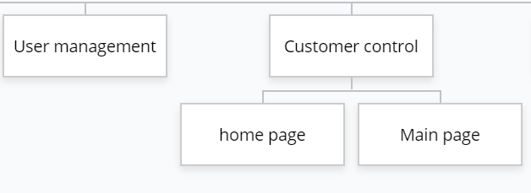



For better quality, please go to this link (https://www.gloomaps.com/ddVx2cz4F7)